Guidance for Topic 5 DQ 1
- As always, first enter your name. Then, the data appear.

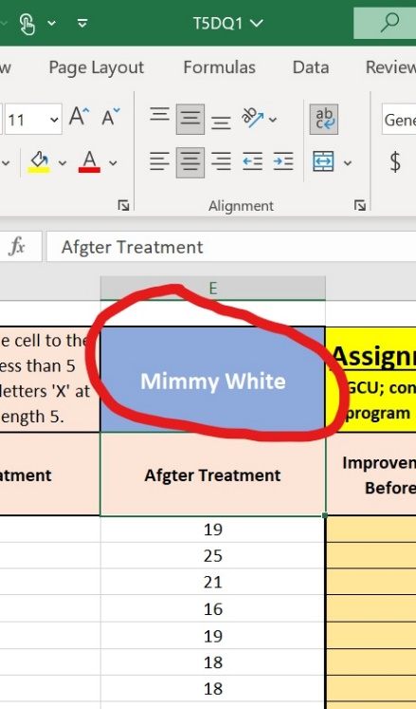

Enter the formula as shown and drag down the formula to fill out column F. You can also use the range formula =E4:E120-D4:D120.
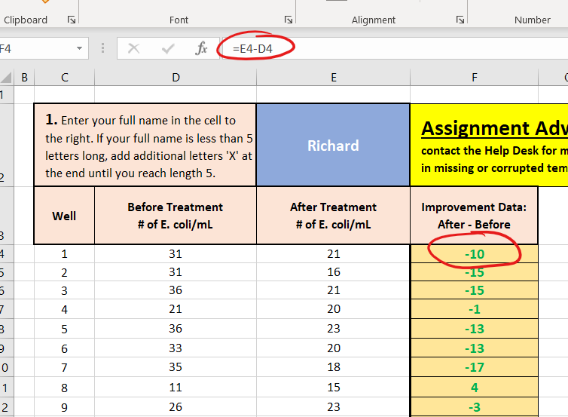

- The following table shows the statistical concept and the appropriate Excel formula(s)

Statistic | Excel Formula | Alternate
Mean | =AVERAGE(DATA)
Median | =MEDIAN(DATA)
Standard Deviation | =STDEV(DATA) | =STDEV.P(DATA) | =STDEV.S(DATA)
Range | =MAX(DATA)-MIN(DATA)

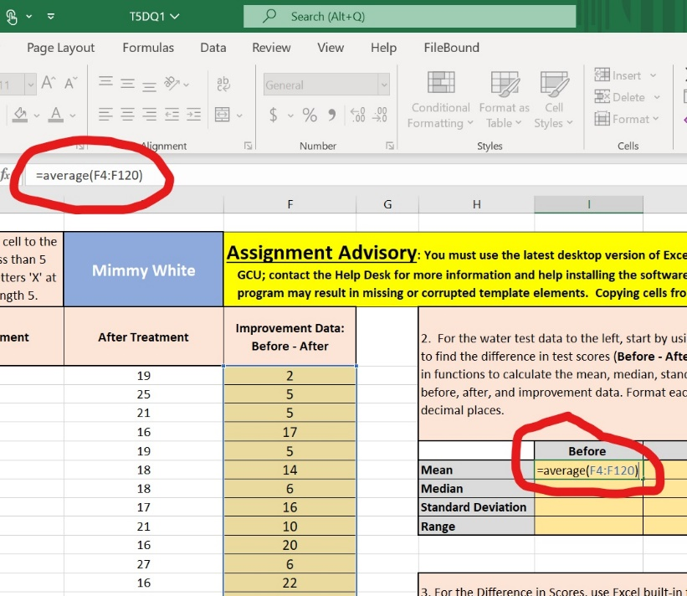

Note: If you correctly fill out any one of the three sections “Before,” “After,” or “Improvement,” then you can use autofill to complate the remaining two.

- Next, you need to find the percentile. The explanation of the percentile function is here: https://support.microsoft.com/en-gb/office/percentile-function-91b43a53-543c-4708-93de-d626debdddca

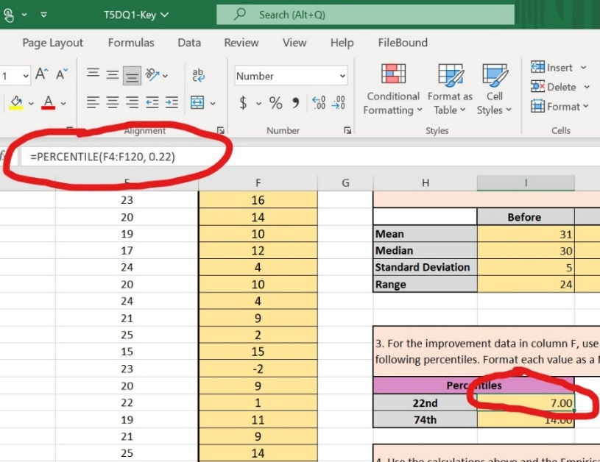

- The explanation about the normal distribution and the empirical rule (68-95-99.7) can be found here: https://www.mathsisfun.com/data/standard-normal-distribution.html (Scroll to the section titles Standard Deviations.)
Here you are asked to use the empirical rule to complete the following sentence

Approximately <some number> of the 117 wells shoe an increase/decrease of between <lower-bound> and <upper-bound>.

Where lower-bound is mean – 1*stdev and upper-bound is mean + 1*stdev. You need this same basic sentence to complete Major Assignment 3.

